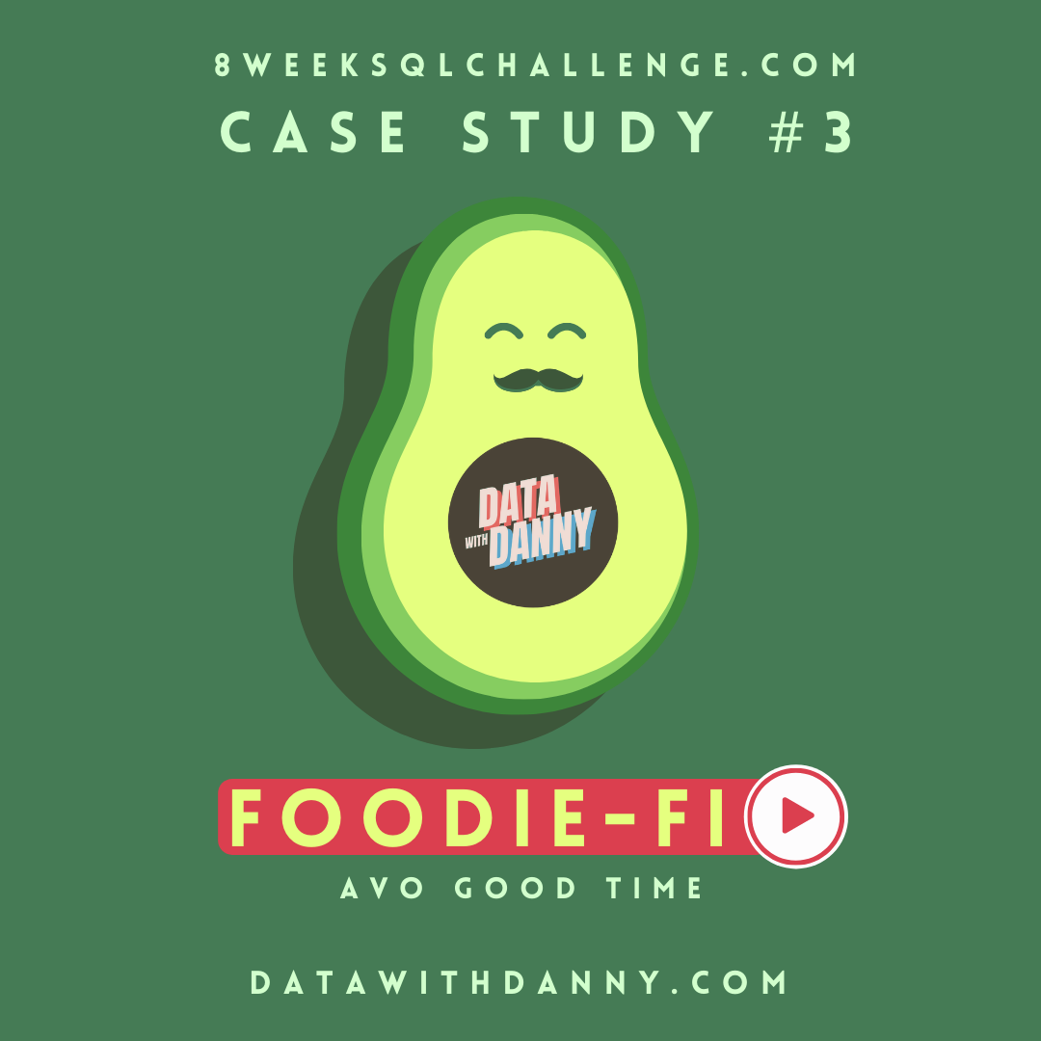

**Introduction**

Subscription based businesses are super popular and Danny realised that there was a large gap in the market - he wanted to create a new streaming service that only had food related content - something like Netflix but with only cooking shows!

Danny finds a few smart friends to launch his new startup Foodie-Fi in 2020 and started selling monthly and annual subscriptions, giving their customers unlimited on-demand access to exclusive food videos from around the world!

Danny created Foodie-Fi with a data driven mindset and wanted to ensure all future investment decisions and new features were decided using data. This case study focuses on using subscription style digital data to answer important business questions.

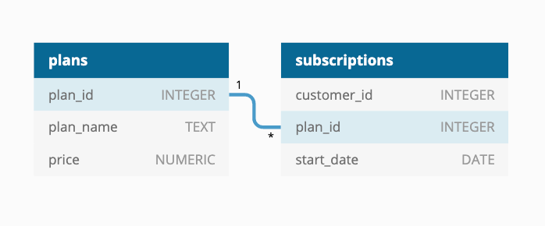

**Table 1: plans**

Customers can choose which plans to join Foodie-Fi when they first sign up.

Basic plan customers have limited access and can only stream their videos and is only available monthly at $9.90

Pro plan customers have no watch time limits and are able to download videos for offline viewing. Pro plans start at $19.90 a month or $199 for an annual subscription.

Customers can sign up to an initial 7 day free trial will automatically continue with the pro monthly subscription plan unless they cancel, downgrade to basic or upgrade to an annual pro plan at any point during the trial.

When customers cancel their Foodie-Fi service - they will have a churn plan record with a null price but their plan will continue until the end of the billing period.

| **plan_id** | **plan_name** | **price** |
| --- | --- | --- |
| 0 | trial | 0 |
| 1 | basic monthly | 9.90 |
| 2 | pro monthly | 19.90 |
| 3 | pro annual | 199 |
| 4 | churn | null |

**Table 2: subscriptions**

Customer subscriptions show the exact date where their specific plan_id starts.If customers downgrade from a pro plan or cancel their subscription - the higher plan will remain in place until the period is over - the start_date in the subscriptions table will reflect the date that the actual plan changes.When customers upgrade their account from a basic plan to a pro or annual pro plan - the higher plan will take effect straightaway.

| **customer_id** | **plan_id** | **start_date** |
| --- | --- | --- |
| 1 | 0 | 2020-08-01 |
| 1 | 1 | 2020-08-08 |
| 2 | 0 | 2020-09-20 |
| 2 | 3 | 2020-09-27 |
| 11 | 0 | 2020-11-19 |
| 11 | 4 | 2020-11-26 |
| 13 | 0 | 2020-12-15 |
| 13 | 1 | 2020-12-22 |
| 13 | 2 | 2021-03-29 |
| 15 | 0 | 2020-03-17 |
| 15 | 2 | 2020-03-24 |
| 15 | 4 | 2020-04-29 |
| 16 | 0 | 2020-05-31 |
| 16 | 1 | 2020-06-07 |
| 16 | 3 | 2020-10-21 |
| 18 | 0 | 2020-07-06 |
| 18 | 2 | 2020-07-13 |
| 19 | 0 | 2020-06-22 |
| 19 | 2 | 2020-06-29 |
| 19 | 3 | 2020-08-29 |

**Case Study Questions**

This case study is split into an initial data understanding question before diving straight into data analysis questions before finishing with 1 single extension challenge.

**A. Customer Journey**

Based off the 8 sample customers provided in the sample from the subscriptions table, write a brief description about each customer’s onboarding journey.

Try to keep it as short as possible - you may also want to run some sort of join to make your explanations a bit easier!

* **Customer id =1**: joined the platform on 1st aug 2020, after the trail period switched to **basic monthly** subscription plan on 27 sept 2020.
* **Customer id =2**: joined the platform on 20th sept 2020, after the trail period switched to **pro annual** subscription plan on 27 sept 2020.
* **Customer id =11**: joined the platform on 19th nov 2020, after the trail period  **discontinued (stopped using the service)** on 26th nov 2020.
* **Customer id =13**: joined the platform on 15th dec 2020, after the trail period switched to **basic monthly** subscription plan on 22 dec 2020, later switched to **pro annual** subscription plan on 29th mar 2021.
* **Customer id =15**: joined the platform on 17th mar 2020, after the trail period switched to **pro monthly** subscription plan on 24th mar 2020, later **discontinued (stopped using the service)** on 29th apr 2020
* **Customer id =16**: joined the platform on 31st may 2020, after the trail period switched to **basic monthly** subscription plan on 7th June 2020, later switched to **pro annual** subscription plan on 21st oct 020.
* **Customer id =18**: joined the platform on 6th jul 2020, after the trail period switched to **pro monthly** subscription plan on 13th jul 2020,
* **Customer id =19**: joined the platform on 22nd June 2020, after the trail period switched to **pro monthly** subscription plan on 29 june 2020, later switched to **pro annual** subscription plan on 29th aug 2020.

**B. Data Analysis Questions**

**1.How many customers has Foodi-FI had?**

* Foodi-Fi has had total of 8 customer as per the given data.
* SQL query used: select count(distinct(customer_id)) from subscriptions;

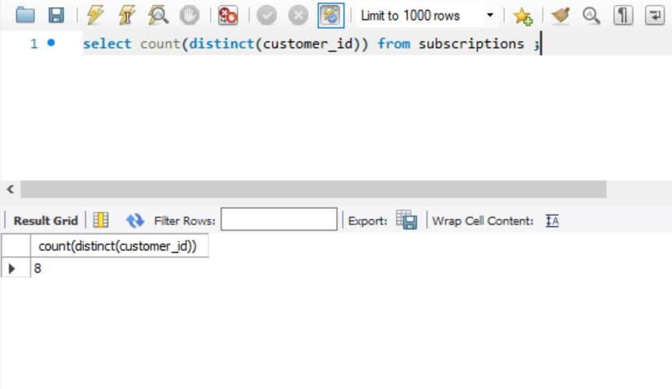

**2.What is the monthly distribution of “trail” plan, “start_date” values for our dataset- use the start of the month as group by value.**

* Query : SELECT * from subscription WHERE plan_id=0 GROUP BY start_date;
* We can see that “trail” plan is evenly, i.e we see that every month has atleast 1 customer who tries the “trail” plan.

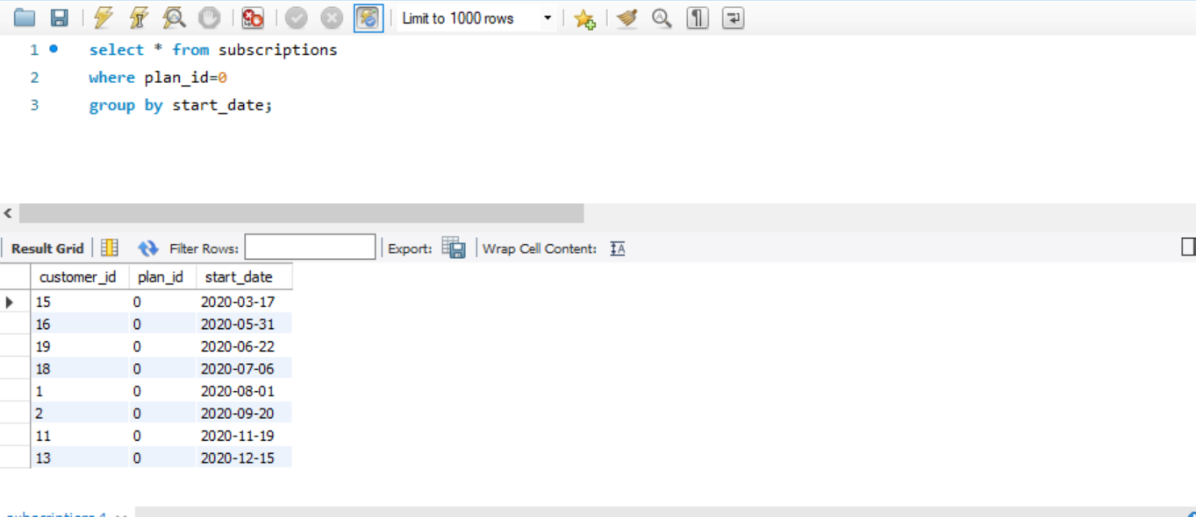

**3.What are the “plans”,”start_date” values occur after the year 2020 for our dataset?**

* Query:

SELECT disctinct(COUNT(customer_id)),plan_id from subscription WHERE YEAR(start_date)>2020;

* We see that customer_id:13, plan_id=2, start_date=2021-03-29.

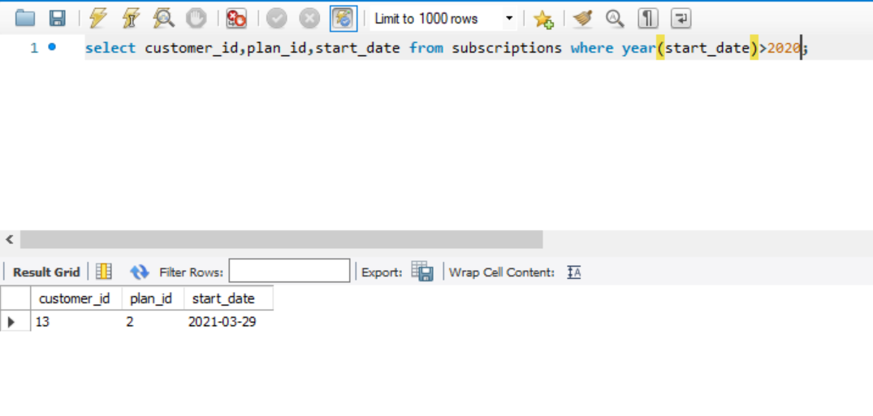

**4.What is the customer count and percentage of customer who have churned ,round to 1 decimal place?**

* Query 1: SELECT * FROM subscriptions WHERE plan_id=4;
* Query 2: SELECT COUNT(*),ROUND(COUNT(*)*100/8,1) percentage FROM subscriptions WHERE plan_id=4;
* Customer count who have churned is: 2
* Percentage of customer churned is: 25%

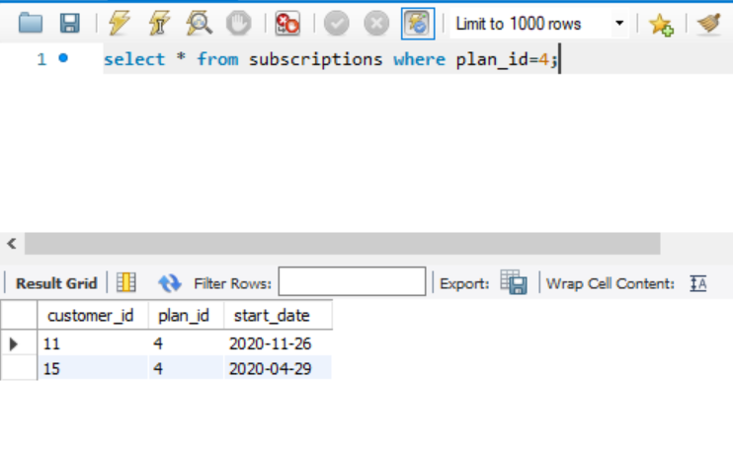

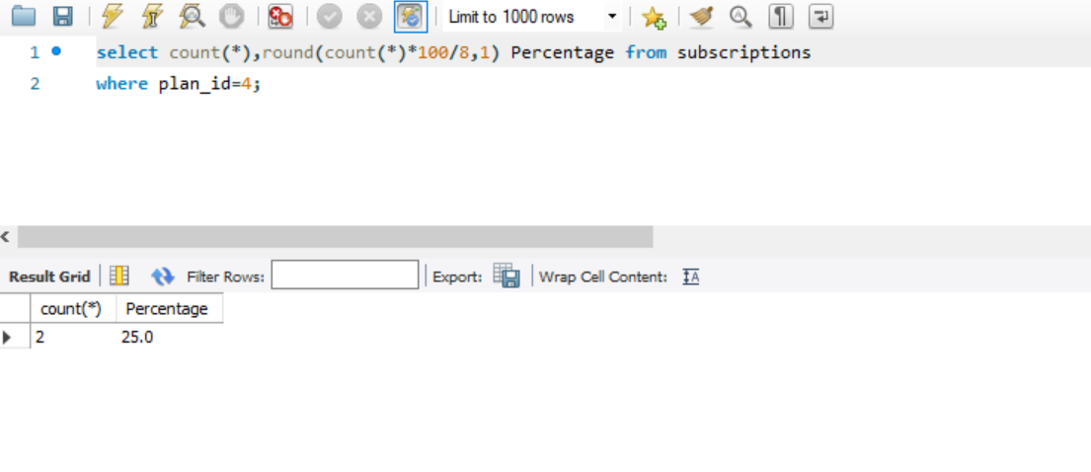

**5.How many customers have churned straight after their initial free trail, what percentage is this round**

**to 1 decimal place?**

* Query: SELECT COUNT(DISTINCT(customer_id)),COUNT(DISTINCT(customer_id))*100/8 percentage FROM subscriptions WHERE plan_id=‘0’ and plan_id=4;
* We see there is only one customer(customer_id=11) directly churned after the trail period the equivalent in percentage is 12.5%.

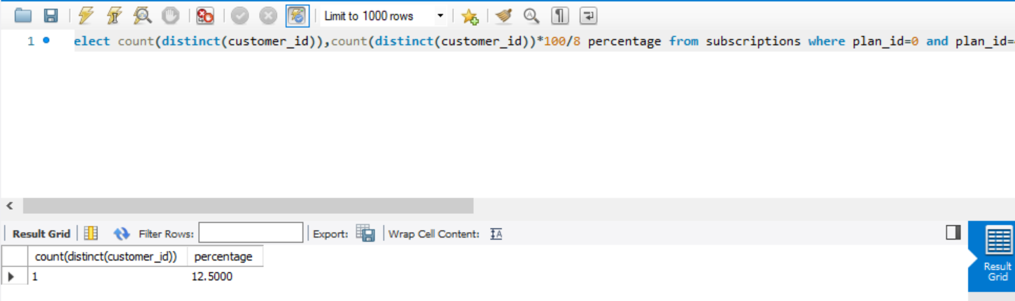

**6.What is the number and percentage of customers who opted plans after their initial free trail?**

* Query: SELECT COUNT(DISTINCT(customer_id)), COUNT(DISTINCT(customer_id))*100/8 percentage FROM subscriptions WHERE plan_id<>0 AND plan_id<>4;
* 7 out of 8 customer opted for plans after free trail, which is equal to 87.5%.

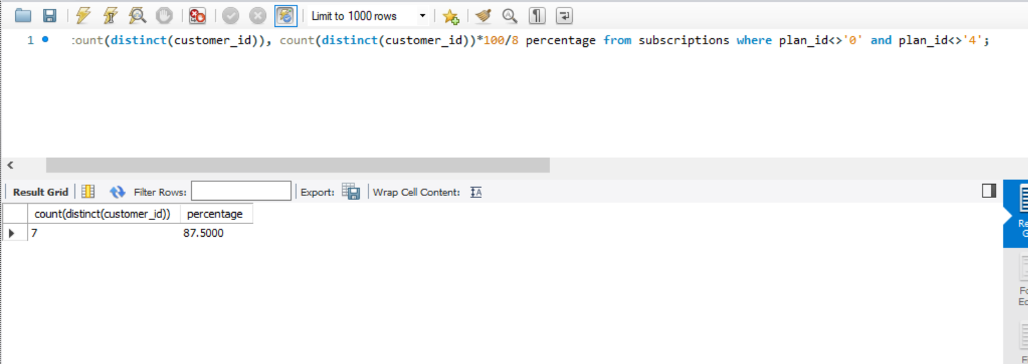

**7.What is the customer count and percentage breakdown of all five plan name value: 2020-12-31?**

* NO DATA RELATED TO DATE: 31-12-2020

**8.How many customers have upgraded to “annual” plan in 2020?**

* Query: SELECT * FROM subscriptions WHERE plan_id=‘3’ AND YEAR(start_date)=‘2020’;
* We see that there are 3 customers who have upgraded to “annual” plan.

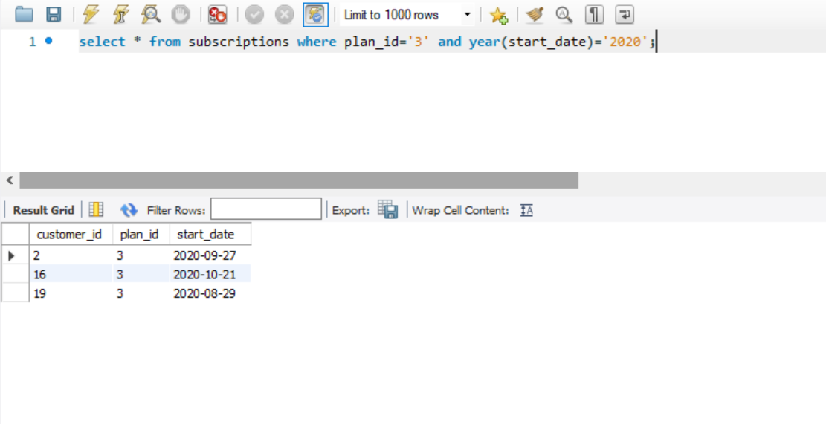

**9.How many days on average does it take for the customer to an “Annual” plan from the day they join Foodi-Fi?**

* Query: SELECT * FROM subscriptions WHERE plan_id=3;
* There are 3 customers who have the “Annual” plan.

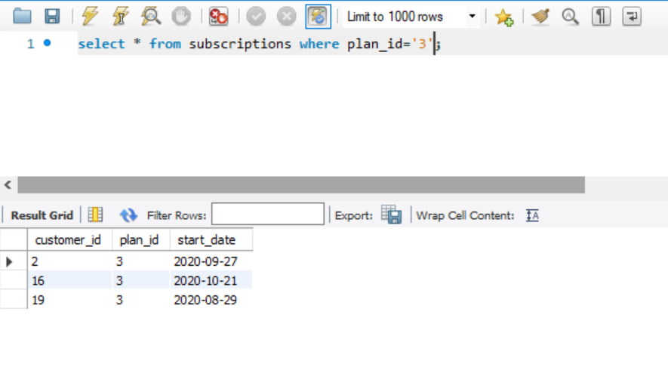

**Customer_id: 2**

* Previous subscription and start_date values
* Query: SELECT DATEDIFF(‘2020-09-27’,‘2020-09-20’)
* Days required by customer_id: 2 to switch to “Annual” plan is : 7 days

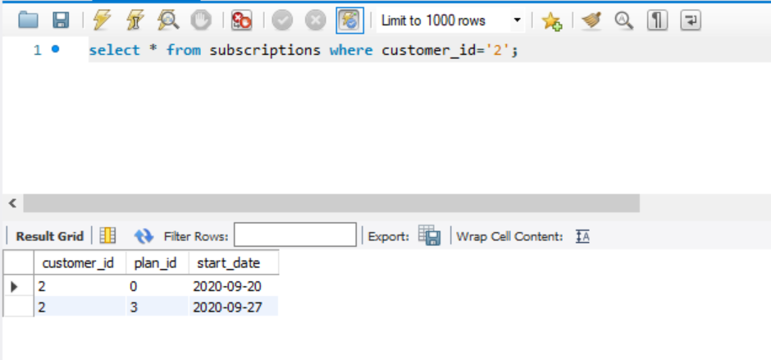

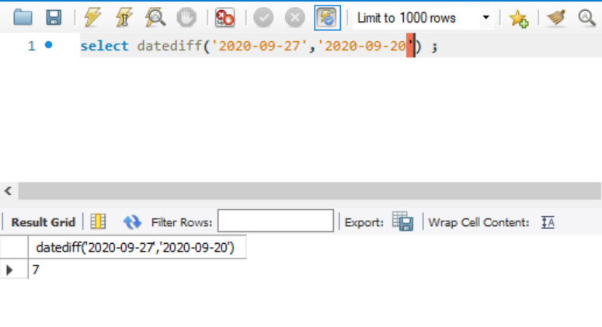

**Customer_id:16**

* Previous subscription and start_ date values
* Query: SELECT DATEDIFF(‘2020-10-21’,‘2020-05-31’)
* Days required by customer_id: 16 to switch to “Annual” plan is : 143 days

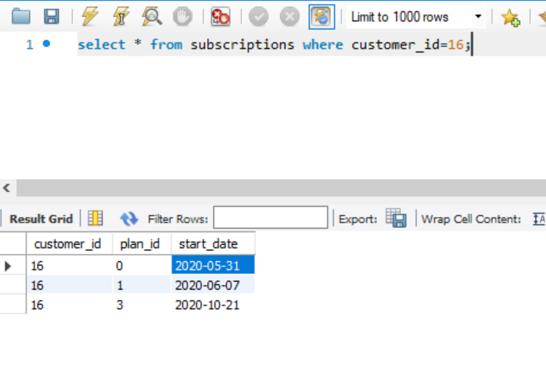

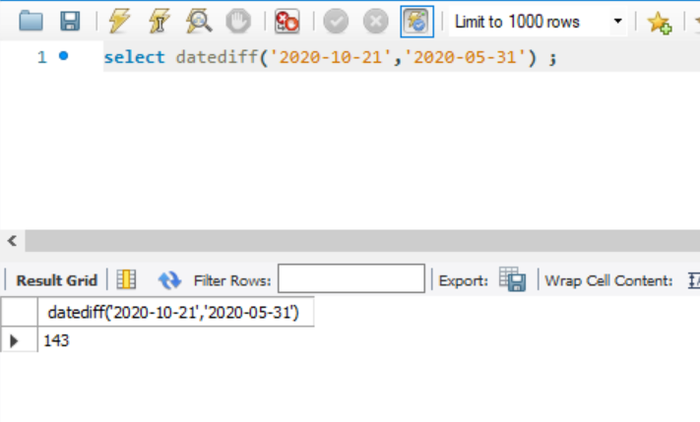

Customer_id: 19

* Previous subscription and start_ date values
* Query: SELECT DATEDIFF(‘2020-08-29’,‘2020-06-22’)
* Days required by customer_id: 19 to switch to “Annual” plan is : 68 days

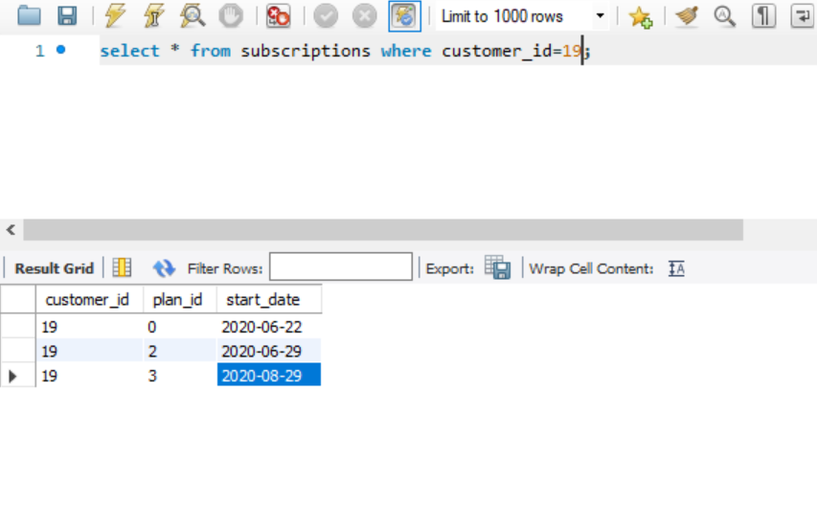

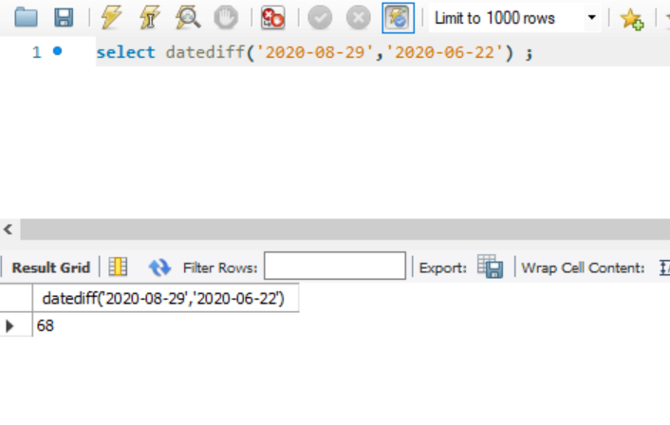

**Average days required**

* Days required by customer_id: 2 to switch to “Annual” plan is : 7 days
* Days required by customer_id: 16 to switch to “Annual” plan is : 143 days
* Days required by customer_id: 19 to switch to “Annual” plan is : 68 days
* Average days = (7+143+68)/3 => 72.66 days

**11.How many customers downgraded from pro-monthly to basic monthly plan in 2020.**

* Query: SELECT * FROM subscriptions WHERE plan_id=‘2’ and plan_id=‘1’ and YEAR(start_date)=‘2020’;
* Zero customers downgraded from pro-monthly to basic monthly plan, as seen below.

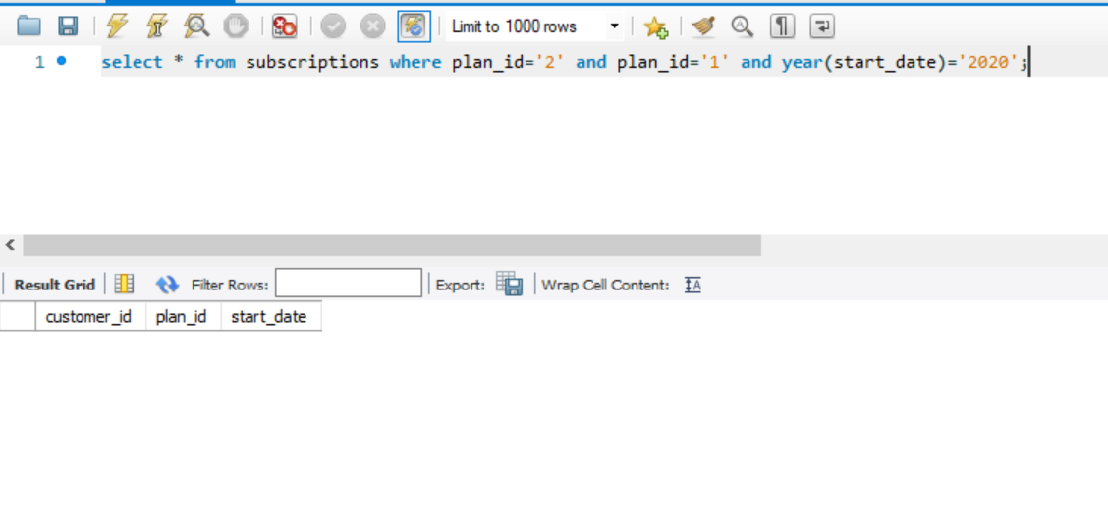

**Challenge payment question**

**Create a table using “subscription” table date.**

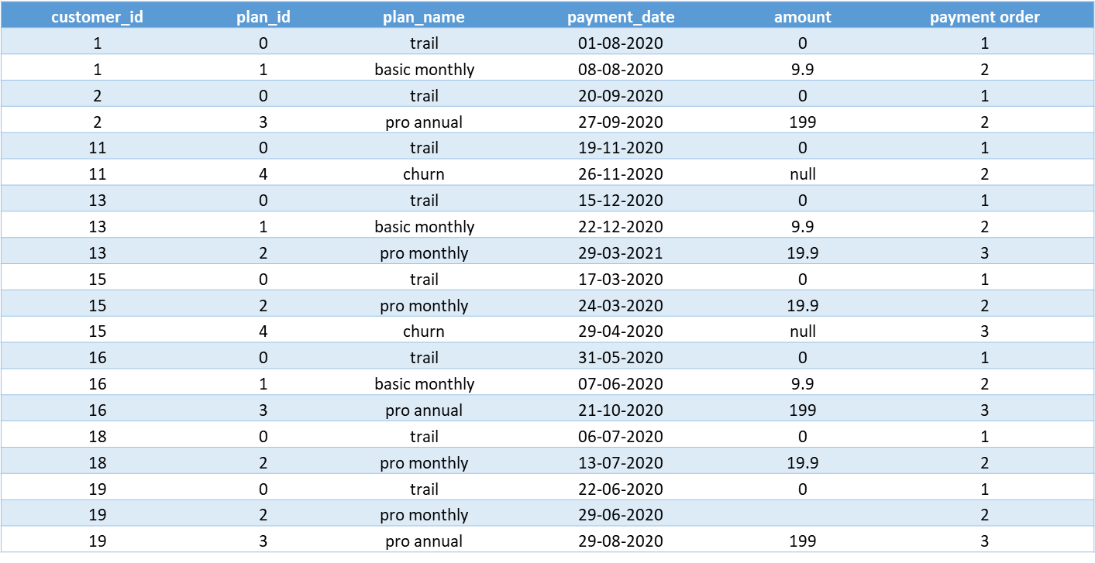

**Outside the box questions**

**1.How would you calculate Foodi-fi’s growth**

* Number of customers opting for plans that generate revenue.
* Number of customer who purchase subscription multiple times, show that platform is holding its audience.
* Accessibility of Foodi-Fi throughout the world, show the platforms reach.
* Variety of shows and their individual performance, which cater to different parts or regions of world, show expansion of content on the platform and can be used to get insights like ”which type of show works in certain parts of the word”.

**2.What are the key metrics would you recommend Foodi-fi management to track over time to assess performance of their overall business?**

* Number of customers who buy subscriptions.
* Markets covered(countries or regions with Foodi-fi access)
* Shows or Which type content is most popular.
* Type of subscription which is most and least popular
  + To make change in plans (like no.of devices ,quality of video etc)
  + To make price changes according to market standards.

**3.What are some key customer journeys or experiences that you would analyze further to improve customer retention?**

* **Languages should be added to content in order to reach wider audience and retain existing customers.**
* **Better advertising and keeping up with trends always helps to attract new customers ,new content which is released on the platform should adverstised in an effective manner to retain customers.**
* **Offers and discounts should be offered on festivals and targeted offers should be offered to customers based on data collected.**
* **Regional shows involving regional stars or known personalities can boost customer count on platform.**
* **Student plans can used to attract younger audience as they consume a lot online media.**

**4.If Foodi-fi team were to create a exit survey shown to customers who wish to cancel their subscription, what questions would you include in the survey?**

* **Did you notice insensitivity in the content towards any religion, race, gender..etc ?**
* **Observed any hateful or abusive content ?**
* **Does the content spread any kind of misinformation?**
* **Did you find the content repeatative?**
* **Is the content poorly made(creatively or technically)?**
* **Didn’t find the content offered up to the mark?**

**5.What business levers could the Foodi-fi team use to reduce the customer churn rate? How would you validate the effectiveness of your ideas?**

* **Take feedback from customers by call, mail. Helps in improving the platform.**
* **Review customer data, find insights and act up on things which are not increasing revenue/profits and fix issues minor inconviences faced by customers.**
* **Regular check-in’s with customer’s**
  + **About viewing experience.**
  + **About offers and discount offers.**